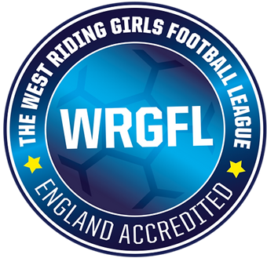

**WRGFL Process for handling and escalating Welfare matters Tier 1 & 2**

**Footnotes are available for all the process steps, to help support the CWO in dealing with Incidents.**

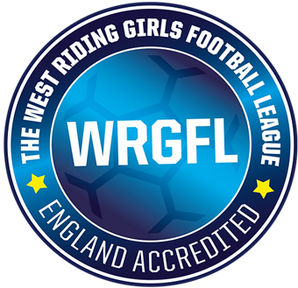

**Footnotes for the process map**

* **Welfare Incident takes place** – Welfare concern takes place either in a training session or on match day.
* **Team Manager to speak with Club WO** – Team Manager to discuss the Incident with their Club Welfare Officer. The club welfare officer will advise you on what the next steps will be. League WO to update the League Management team on the Incident raised.
* **Club WO complete the WRGFL Investigation Summary Form** – Club WO will need to add all the relevant information to the Investigation summary form. This will help organize all the correct information and evidence you may have regarding the incident. Once this is completed it needs to be emailed to the opposing Club WO and the League WO, the League Sec will also need to be CC into the email. The League WO will liaise with the League Management Committee to ensure everyone has the current update.
* **Opposing Club WO have 14 days to respond back with their findings** - Using the League investigation summary form, also adding their findings and action or actions, they will be taking regarding the incident. At this point, it is hoped the desired outcome can be achieved at a local level between both clubs. League WO office to update the League Management Committee.
* **Both Clubs agree on the desired outcome** – This is where the process concludes and the case will be closed by the League WO.

League WO to update the Management Committee.

* **Local desired outcome cannot be achieved** – At this point all evidence from Investigation summary forms and all evidence collected need to be sent to the League welfare officer with an understanding of why a Local area’s desired outcome cannot be achieved. League WO to update the Management Committee.
* **League WO to review and collect any further information** – League welfare officer to review the full Investigation and evidence. It’s the League WO to arrange the next steps. League WO to update the Management Committee.
* **League WO to speak with both Club WO** – The League WO will speak with both Club welfare officers and look to arrange a desired League outcome. If a league’s desired outcome is achieved where the case will be updated and closed by the League WO.

League WO to update the Management Committee.

**League Welfare Officer cannot agree on a local area outcome. Pass to WRCFA** – At this point, the League welfare officer will add their Investigation summary to all previous paperwork and email WRCFA. League WO to update the Management Committee.

* **WRCFA to review all the investigation information and decide on the incident** – West Riding Country will make the final decision on the case and inform the League WO & Club WO OF the official outcome. League WO to update the Management Committee.